Directions: Read the excerpt from this classic poem about a seaman’s journey. Prepare for discussion about its’ meaning and connections to our water war.
A couple of strategies to use in approaching this assignment:
- If you can’t figure out how something is pronounced, like mariner, use https://www.thefreedictionary.com/mariner
- Similarly, if context clues don’t help you in understanding what something means, also use https://www.thefreedictionary.com/mariner
- If something still doesn’t make sense to you, then quietly ask someone at your table if they have figured it out.
- If neither of you have figured it out, then put a bigbeside it, and make sure to ask about it when we are talking as whole class.

An Excerpt from Part 2 of Samuel Taylor Coleridge’s,
FYI: The ship is sailing north into the Pacific Ocean.
“The Rime of The Ancient Mariner”

The fair breeze blew, the white foam flew,
The furrow followed free;
We were the first that ever burst
Into that silent sea!

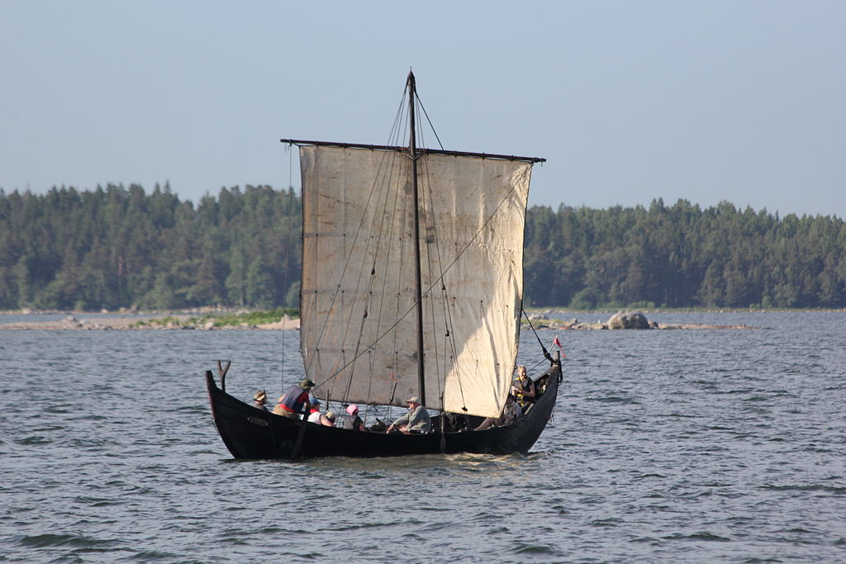
Down dropt the breeze, the sails dropt down,
‘Twas sad as sad could be;
And we did speak only to break
The silence of the sea!

All in a hot and copper sky,
The bloody Sun, at noon,
Right up above the mast did stand,
No bigger than the Moon.

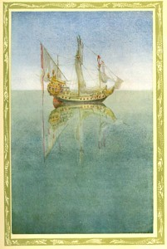
Day after day, day after day,
We stuck, nor breath nor motion;
As idle as a painted ship
Upon a painted ocean.

Water, water, every where,
And all the boards did shrink;
Water, water, every where,
Nor any drop to drink.

Initial Thinking: (Prepare for Discussion)
- What do you think this section of “The Rime of the Ancient Mariner” is about?
________________________________________________________________________________________________________________________________________________________________________________________________________________________
- How do you think these experiences connect to our current water war?
________________________________________________________________________________________________________________________________________________________________________________________________________________________
- What do you think is the actual amount of fresh water available for human use? Use a percentage to represent your thinking. ____________________

Next Steps: Mathematical Models
- Pie Charts
- Familiarize yourself with the data. (https://water.usgs.gov/edu/earthwherewater.html)
- Revise Pie Charts
- What would these distributions of water look like in a graduated cylinder?

